- Open https://osp.osmsinc.com/FultonGA/
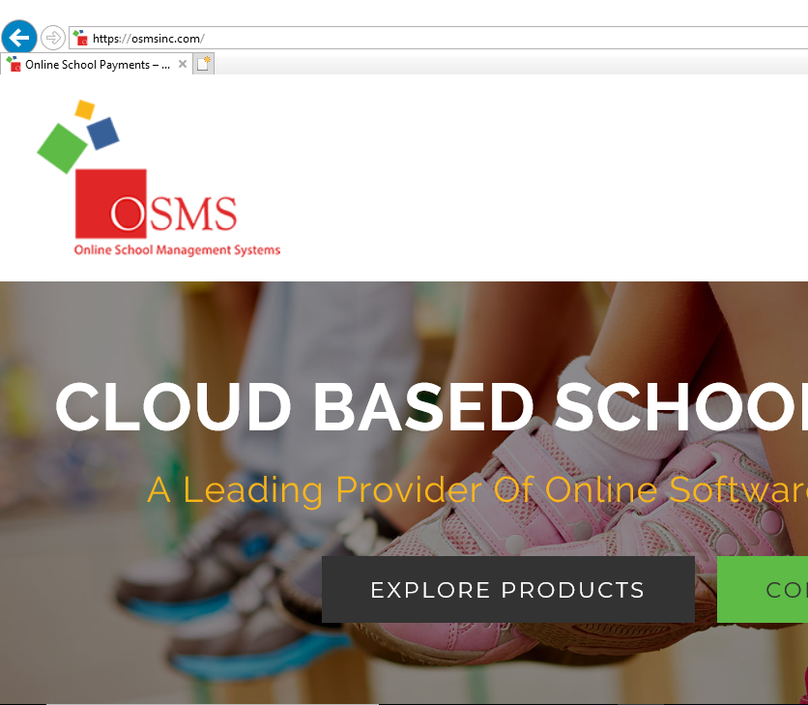

- Click “sign in” or click on “middle”

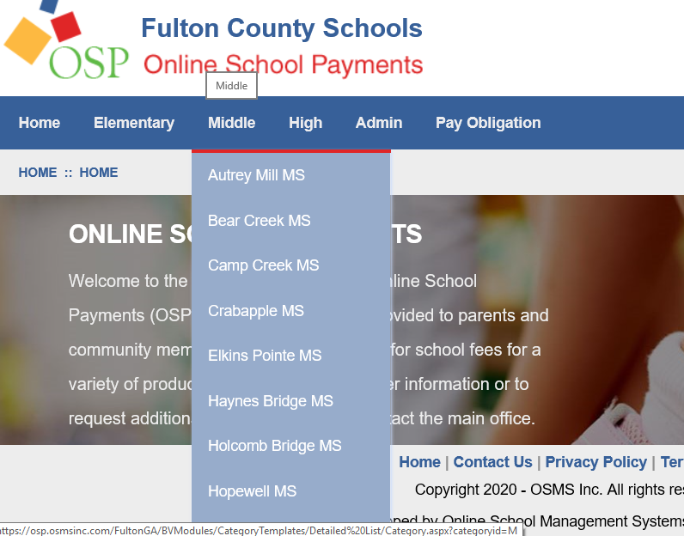

- Scroll down to “Webb Bridge”. Click.
- Click on the search icon
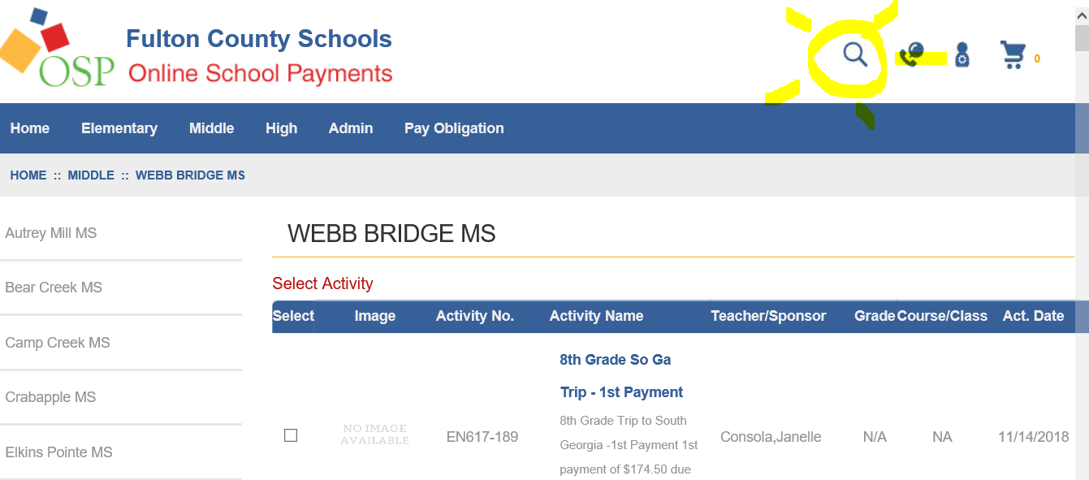
- Search for the keyword “Chorus” and enter “Webb Bridge” as the school. Click “search.”
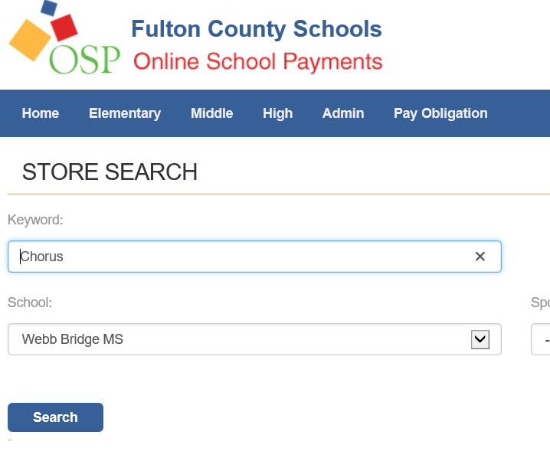
Select the following:
6th Graders: Activity fee, either the formal uniform dress or formal uniform shirt, the informal uniform t-shirt. In addition, you may order spirit-wear if you’d like.
7th and 8th Graders: Activity fee, any uniform pieces you do not have from last year. In addition, you may order spirit-wear if you’d like.

- Scroll down and click “Add to Cart.”

- Click “Checkout”
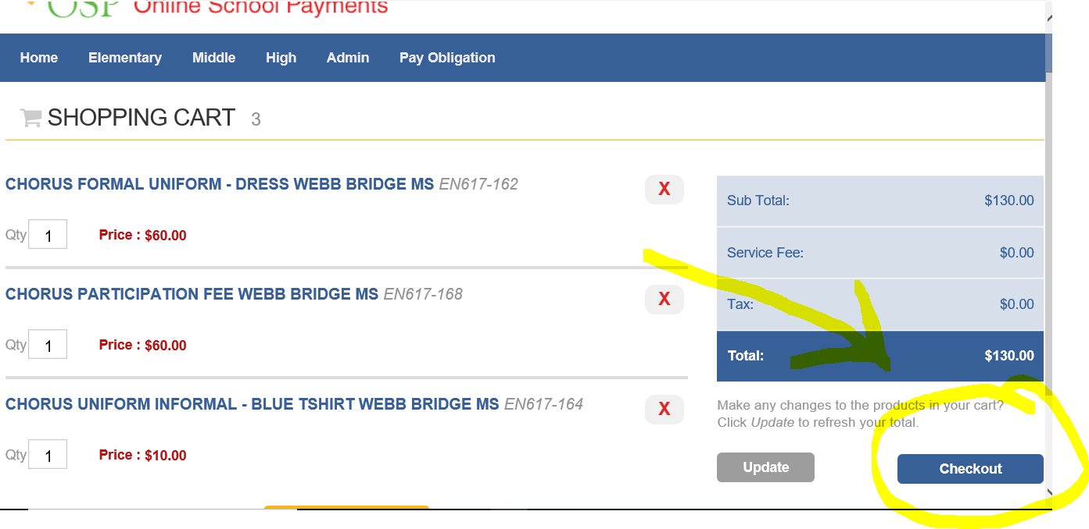

- Ask your children for a huge hug and thank you! We appreciate all that you do to support our work in Chorus!

